**Module 5 - Spring Core and Maven**

**Exercise 7: Implementing Constructor and Setter Injection**

**Aim:**

The library management application requires both constructor and setter injection for better control over bean initialization.

**Structure:**

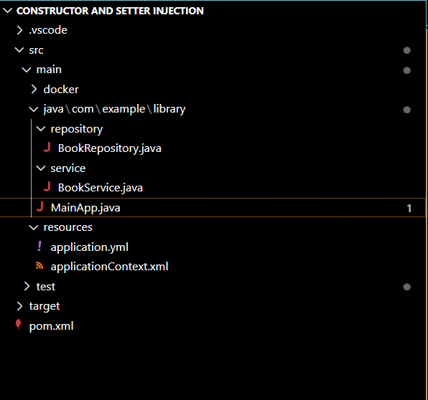

package com.example.library.repository;

public class BookRepository {

    public void saveBook() {

        System.out.println("Book saved to repository.");

    }

}

package com.example.library.service;

import com.example.library.repository.BookRepository;

public class BookService {

    private BookRepository bookRepository;

    // Constructor injection

    public BookService(BookRepository bookRepository) {

        this.bookRepository = bookRepository;

        System.out.println("Constructor injection called.");

    }

    // Setter injection

    public void setBookRepository(BookRepository bookRepository) {

        this.bookRepository = bookRepository;

        System.out.println("Setter injection called.");

    }

    public void addBook() {

        System.out.println("Adding book...");

        bookRepository.saveBook();

    }

}

package com.example.library;

import com.example.library.service.BookService;

import org.springframework.context.ApplicationContext;

import org.springframework.context.support.ClassPathXmlApplicationContext;

public class MainApp {

    public static void main(String[] args) {

        ApplicationContext context = new ClassPathXmlApplicationContext("applicationContext.xml");

        BookService bookService = context.getBean("bookService", BookService.class);

        bookService.addBook();

    }

}

<?xml version="1.0" encoding="UTF-8"?>

<beans xmlns="http://www.springframework.org/schema/beans"

       xmlns:xsi="http://www.w3.org/2001/XMLSchema-instance"

       xsi:schemaLocation="

           http://www.springframework.org/schema/beans

           http://www.springframework.org/schema/beans/spring-beans.xsd">

    <!-- BookRepository Bean -->

    <bean id="bookRepository" class="com.example.library.repository.BookRepository"/>

    <!-- BookService Bean with both constructor and setter injection -->

    <bean id="bookService" class="com.example.library.service.BookService">

        <!-- Constructor Injection -->

        <constructor-arg ref="bookRepository"/>

        <!-- Setter Injection -->

        <property name="bookRepository" ref="bookRepository"/>

    </bean>

</beans>

<project xmlns="http://maven.apache.org/POM/4.0.0"

         xmlns:xsi="http://www.w3.org/2001/XMLSchema-instance"

         xsi:schemaLocation="http://maven.apache.org/POM/4.0.0

                             http://maven.apache.org/xsd/maven-4.0.0.xsd">

    <modelVersion>4.0.0</modelVersion>

    <groupId>com.example</groupId>

    <artifactId>LibraryManagement</artifactId>

    <version>1.0-SNAPSHOT</version>

    <packaging>jar</packaging>

    <properties>

        <maven.compiler.source>1.8</maven.compiler.source>

        <maven.compiler.target>1.8</maven.compiler.target>

    </properties>

    <dependencies>

        <!-- Spring Context (IoC Container) -->

        <dependency>

            <groupId>org.springframework</groupId>

            <artifactId>spring-context</artifactId>

            <version>5.3.36</version>

        </dependency>

    </dependencies>

    <build>

        <plugins>

            <!-- Compiler plugin -->

            <plugin>

                <groupId>org.apache.maven.plugins</groupId>

                <artifactId>maven-compiler-plugin</artifactId>

                <version>3.10.1</version>

                <configuration>

                    <source>1.8</source>

                    <target>1.8</target>

                </configuration>

            </plugin>

            <!-- Exec plugin to run Main class -->

            <plugin>

                <groupId>org.codehaus.mojo</groupId>

                <artifactId>exec-maven-plugin</artifactId>

                <version>3.1.0</version>

                <configuration>

                    <mainClass>com.example.library.MainApp</mainClass>

                </configuration>

            </plugin>

        </plugins>

    </build>

</project>

**Output:**

